**R ASSESMENT 1**

1. Say True or False for the below statements:

a. Base R packages installed automatically? - **False**

b. The number of values in each Elements of a list, should be equal. - **False**

c. Data frames and matrices are two dimensional however the array is

multidimensional. **-True**

2. What is Recycling of elements in a vector? Give an example of recycling of elements.

OR

Explain different data types in R with examples.

**Ans: When applying an operation to two vectors that requires them to be the same length, R automatically recycles, or repeats, elements of the shorter one, until it is long enough to match the longer Vector.   
  
Suppose we have two Vectors c(1,2,4) , c(6,0,9,10,13), where the first one is shorter with only 3 elements. Now if we sum these two, we will get a warning message as follows.  
> c(1,2,4) + c(6,0,9,10,13)  
[1]  7  2 13 11 15  
Warning message:  
In c(1, 2, 4) + c(6, 0, 9, 10, 13) :  longer object length is not a multiple of shorter object length  
  
Here R , Sum those Vectors by Recycling or repeating the elements in shorter one, until it is long enough to match the longer one as follows..  
  
> c(1,2,4,1,2) + c(6,0,9,10,13)  
[1]  7  2 13 11 15**

OR

Different data types in R

* **character: "a", "swc"**
* **numeric: 2, 15.5**
* **integer: 2L (the L tells R to store this as an integer)**
* **logical: TRUE, FALSE**
* **complex: 1+4i (complex numbers with real and imaginary parts)**

3. What should be the output of the following Script?

v <- c( 2,5.5,6)

t <- c(8, 3, 4)

print(v%/%t)

**Ans: [1] 0 1 1**

4. Write following user defined functions using R (any 3):

a. increment() with 2 arguments “number” and “by”. Which increments a no. by 1

b. printnumbers() which can print nos. from 1 to 20

**x=c(1,2,3,4,5,6,7,8,9,10,11,12,13,14,15,16,17,18,19,20)**

**for (i in x){**

**print(i)**

**}**

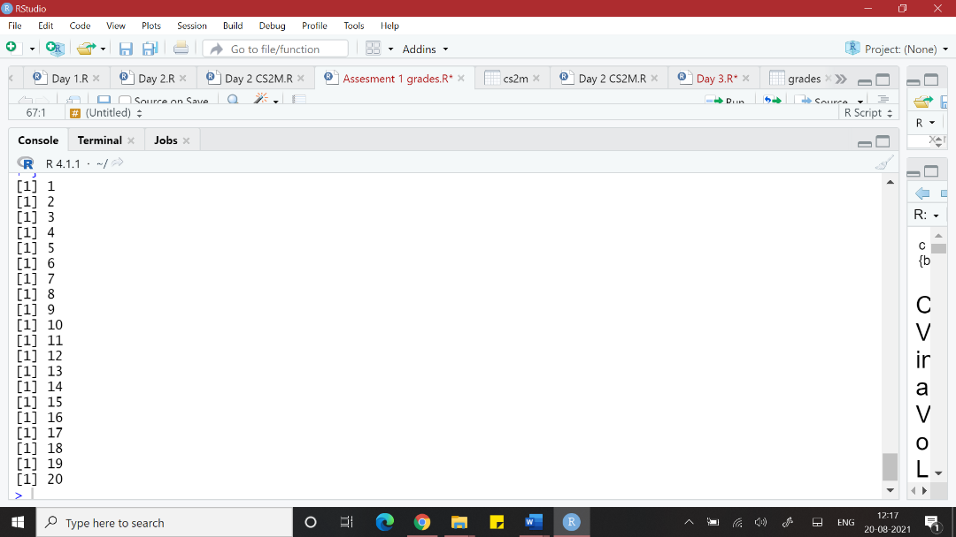

c. printletters() which prints alphabets from “A” TO “H”

**v<-LETTERS[1:8]**

**for (i in v){**

**print(i)**

**}**

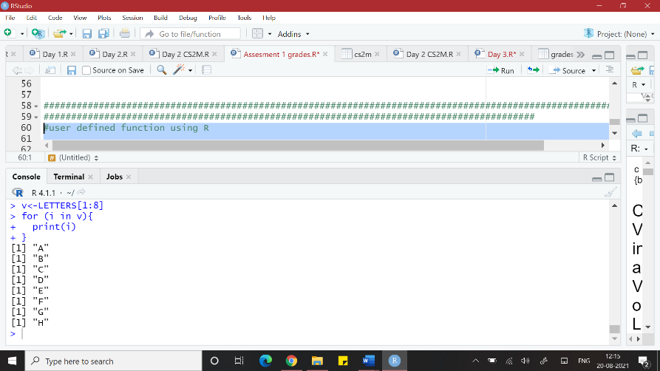

d. mysort() which can sort the values of a vector in ascending order

e. mydivision() which returns quotient and remainder.

5. Write a R code for the following :

a. Create a dataframe named “mydf “ with 4 columns “name”,”age”,”salary” and

“hobby” and 6 observations.

**#Create the data frame.**

**mydf.data <- data.frame(**

**"Name" = c("Rohini","Sagar","Neeti","Madhu","Alaka"),**

**"Age" = c(24,20,33,21,26),**

**"Salary" = c(8723.3,9515.2,7611.0,7329.0,5343.25),**

**"Hobby" = c("Dance", "Painting", "Singing", "Photography","Reading"),**

**stringsAsFactors = FALSE**

**)**

**#print the data frame.**

**print(mydf.data)**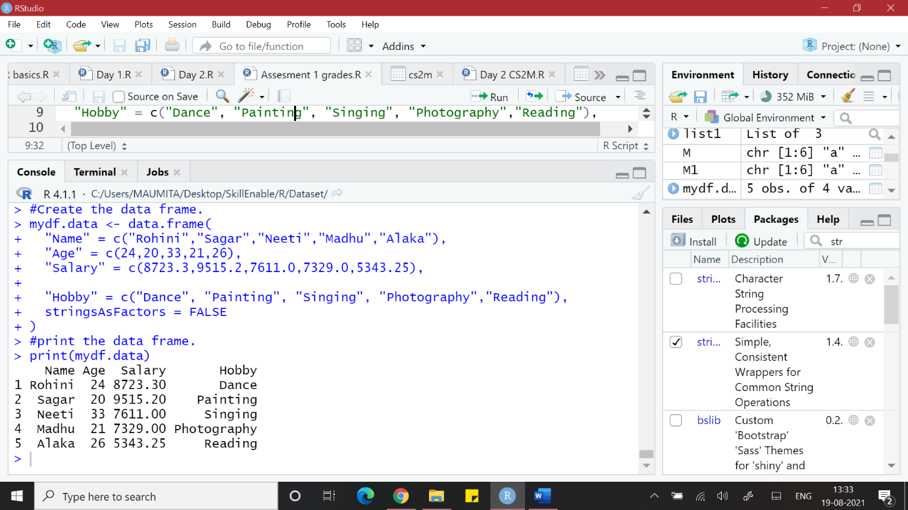

b. Change the column names to “empname”,”empage”,”empsalary” and “emphobby”

**#Change column name in the data frame.**

**mydf.data <- data.frame(**

**"Name" = c("Rohini","Sagar","Neeti","Madhu","Alaka"),**

**"Age" = c(24,20,33,21,26),**

**"Salary" = c(8723.3,9515.2,7611.0,7329.0,5343.25),**

**"Hobby" = c("Dance", "Painting", "Singing", "Photography","Reading"),**

**stringsAsFactors = FALSE**

**)**

**#print the original data frame.**

**print("Original data frame")**

**print(mydf.data)**

**# assigning new names to the columns of the data frame**

**colnames(mydf.data) <- c('empname','empage','empsalary','emphobby')**

**#print the new data frame.**

**print("New data frame")**

**print(mydf.data)**

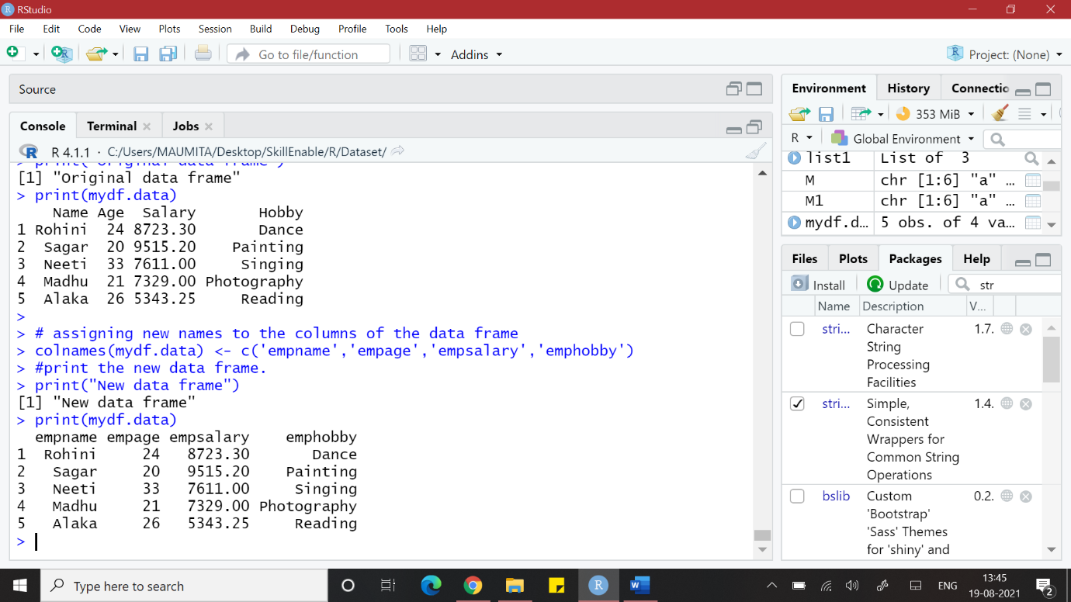

c. Save/Export the dataframe in .csv and .xlxs format

**getwd()**

**setwd("C:\\Users\\MAUMITA\\Desktop\\SkillEnable\\R\\Dataset")**

**#Exporting table to a CSV file**

**data <-data.frame(x1 = c(1,2,3,4), x2=c(5,6,7,8), x3=c(9,10,11,12))**

**data**

**write.table(data, file = "data.csv", sep="\t", row.names=FALSE)**

**list.files()**

**#Exporting R data to an excel spreedsheet**

**install.packages("xlsx")**

**library(xlsx)**

**write.xlsx(data,"data.xlsx")**

**#Exporting data from R to SPSS**

**install.packages("foreign")**

**library(foreign)**

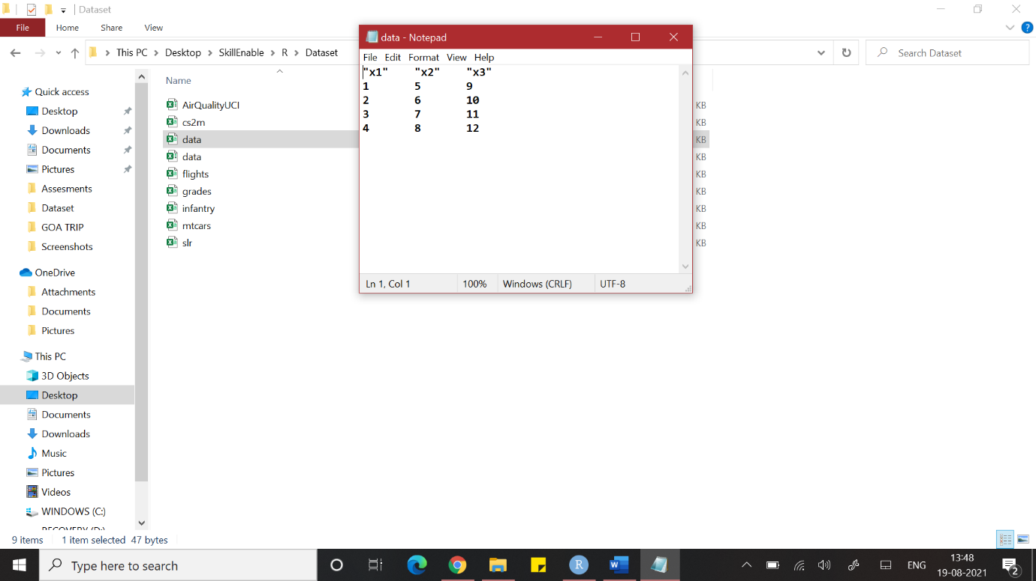

6. Import the dataset named “grades.csv” and perform any 5 basic statistics operations

using R.

**library(readr)**

**grades <- read_csv("C:/Users/MAUMITA/Desktop/SkillEnable/R/Dataset/grades.csv")**

**View(grades)**

**dim(grades)**

**#How many observations in particular variable**

**length(grades$ethnicity)**

**min(grades$ethnicity)**

**max(grades$ethnicity)**

**range(grades$ethnicity)**

**sum(grades$ethnicity)**

**median(grades$ethnicity)**

**var(grades$ethnicity)**

**sd(grades$ethnicity)**

